` CO1 ASSESSMENT TOOL
OUTPUT PREDICTION

NAME :K.Divya
REG NO:192511316
COURSE:Data Structure
CODE:0307

1.write a C program that takes array as an input and return it reversed 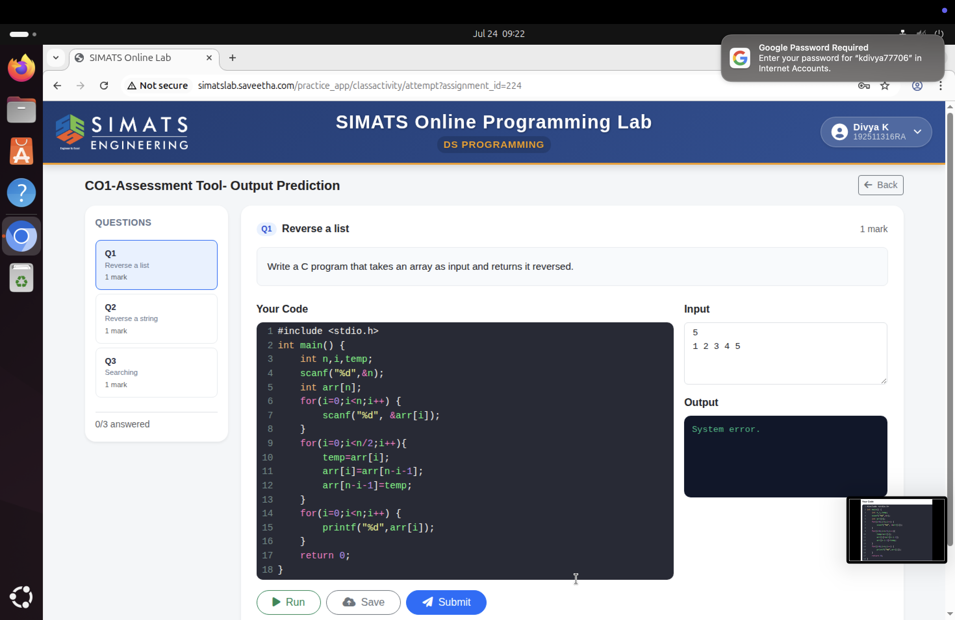
2.Write a C program for palindrom

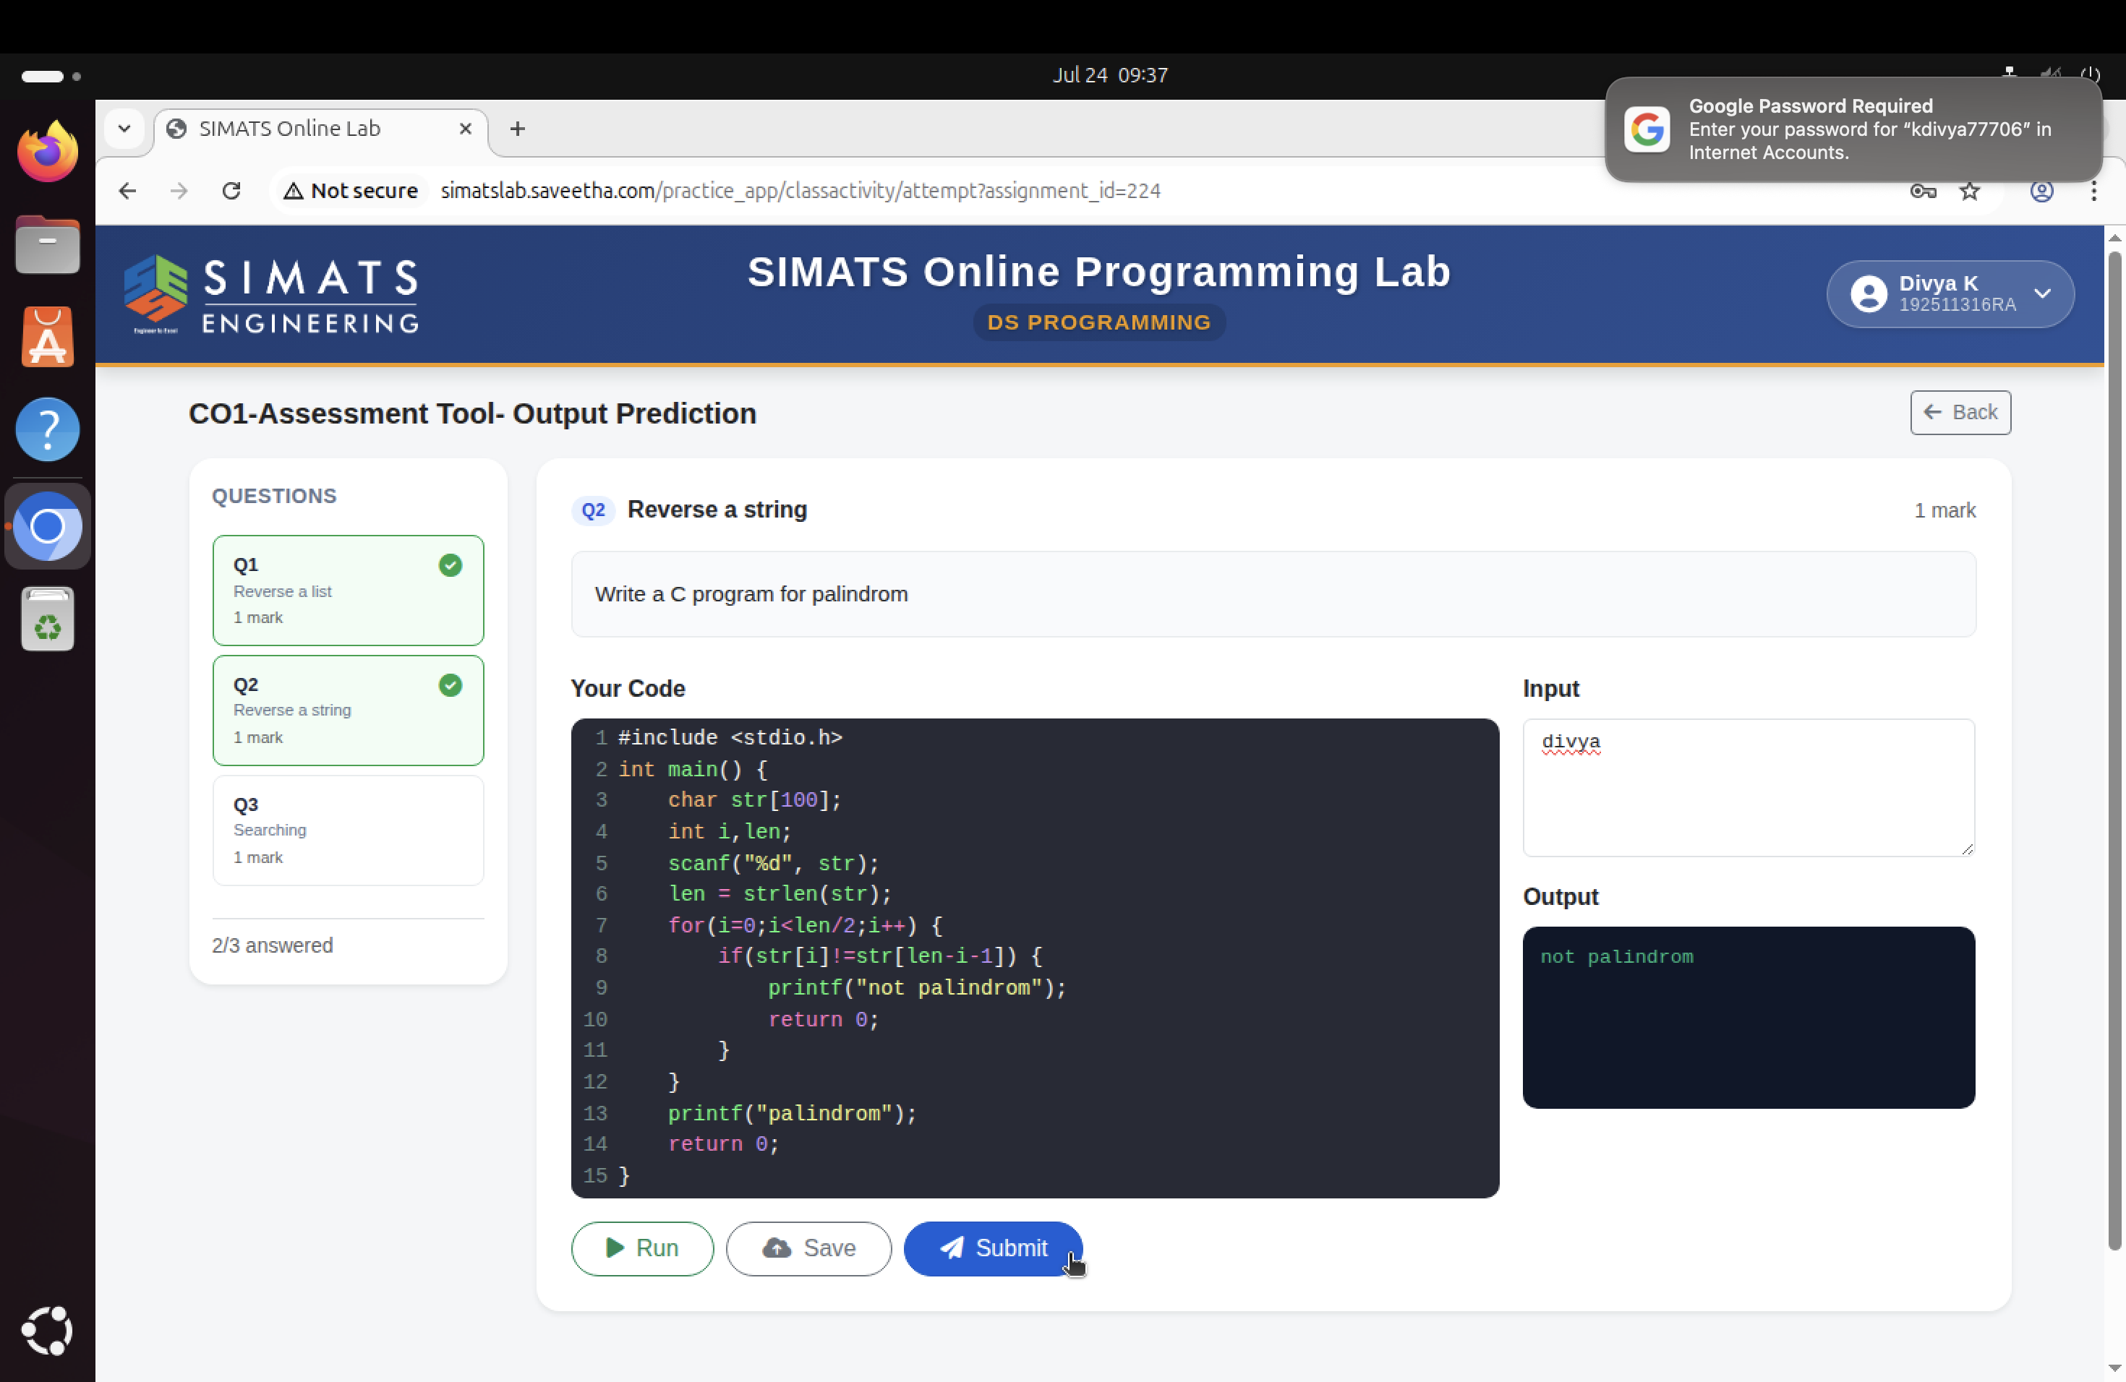

3.Write a c program code for searching an element in a sorted array

